Accessible chart 2 description

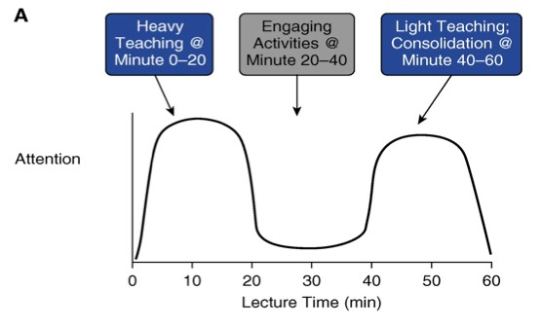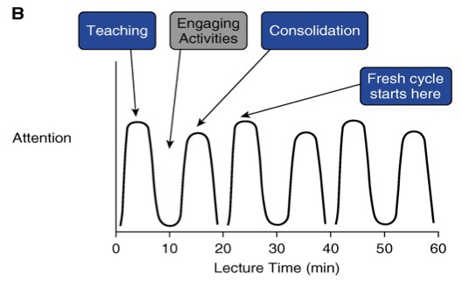

The chart illustrates two models of teaching based on attention (axis Y) and lecture time in minutes (axis X). In both models, a lecture that takes 60 minutes in total is illustrated.
In model A, teaching phases are done in 20-minute cycles. Heavy teaching takes place in the first 20 minutes of the lecture with great attention from students. Engaging activities are done for the next 20 minutes with low attention from students. In the last 20 minutes of the lecture, there is light teaching, focusing on consolidating the learning with high attention from students.
In model B, teaching phases are done around 20-minute cycles. Teaching takes place in the first 10 minutes when students' level of attention is high. Right after, when attention is low, students will do engaging activities, increasing their attention again. Consolidation takes place in the last 10 minutes, when attention is high again. The class is composed of three cycles of 20 minutes.

