Chart accessibility 1

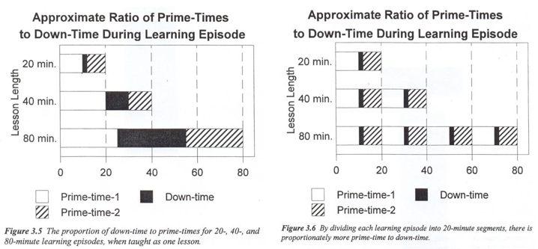

Image displays 2 charts. They are both titled: “approximate ratio of prime-times to down-time during learning episode. In chart 1, the proportion of down-time to prime-times when taught as one lesson for 20 minutes learning episodes is 10 minutes of Prime-time-1, 2 minutes of Down-time and 8 minutes of Prime-time-2. For 40 minutes learning episodes is 20 minutes of Prime-Time-1, 10 minutes of Down-time and 10 minutes of Prime-time-2. For 80 minutes learning episodes where the time is split between ⅓ Prime-time-1, ⅓ Down-time and ⅓ Prime-time-2.
In chart 2, by dividing each learning episode into 20-minute segments, there is proportionately more prime-time to down-time. In each 20 minute segment, where is in 20, 40 or 80 minutes learning episodes, there are always 10 minutes of Prime-time-1, 2 minutes of Down-time, 8 minutes of Prime-time-2.

